FOR IMMEDIATE RELEASE

ANTONAKOS
Whites
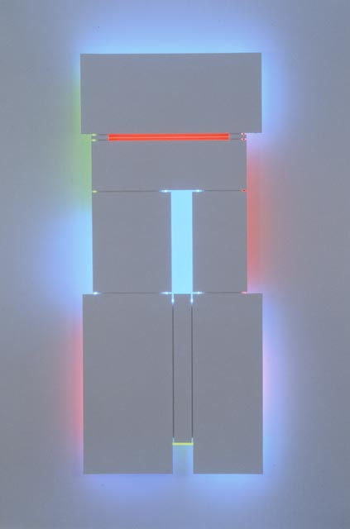
February 17 – March 20, 2010
Opening reception Wed., February 17, 6 to 8pm

Lori Bookstein Fine Art is pleased to present Antonakos: Whites, an exhibition of the artist’s white work in various media and different scales, focusing on the interaction of light with particular surfaces and edges. Drawn from the last 30 years, the examples embody the formalist engagement with physical and spatial relationships that has defined the work since the mid-1960s. Consistently non-referential, his geometric abstractions are, in his own words, “real things in real space.”

The interdependence of light and space, and the concern for specific architectural context and scale, that this exhibition seeks to exemplify, were powerfully evident in the 1960s in successive one-person exhibitions in New York and throughout the country. These included shows at the Fischbach Gallery, New York City; Neon Sculpture at the Fort Worth Art Center, and The Magic Theatre at the Nelson Atkins Gallery, Kansas City, among others.

Through the 1970s, many series of smaller, succinct “incomplete” neon forms in indoor installations were VOYAGE (1999)
exhibited in dozens of personal and group shows here
and throughout the United States and Europe. These crucially-placed linear forms referred to whole circles, squares, and other geometric shapes that might be completed in much larger scale in the mind’s eye. Antonakos dealt with these forms at the same time with a great range of invention in his drawings. These continue to be steadily produced, as shown in the group of recent “Crumples” – sheets of paper and Tyvek which the artist has quickly, firmly manipulated by hand.

Like the “Crumples” and all the artist’s works on paper and vellum, the earliest works here, the “Cuts” (1978, 1980), were created with Antonakos’s characteristic “plan/no plan.” Decisions are made regarding materials, scale, and general approach. Then there is an almost complete abandonment of conscious intention, and the hand leads the process. Both the “Crumples” and the “Cuts” offer a subtle invitation to the third dimension. This imaginative aspect is indicative of a temperament “so often concerned not with what is visible but with what is implied or concealed or incomplete.”

The specific motifs in the three wood Reliefs sprang from a series of Artist’s Books produced by hand in the 1980s. Their various jam-packed and spare compositions have been noted as relating to Constructivism. They reveal perhaps a harder, more rigorous aspect of the art.

Antonakos’s geometric Panels began in the early 1980s. Along with the public commissions, these are probably his best-known works. The segmented Panels (begun in the early 1990s) are deeply engaged with composition, proportion, the relationships between the elements within a work, and those between the work as a whole and the architecture and space around them. The chromatic glows of neon from behind their edges – and sometimes between the planes – affect both the wall and the space that we occupy as viewers.

Through the 1980s and 90s, aside from the circles and an occasionally slanted left or right side, the Panels remained structured orthogonally. “Voyage” (1999) is a stately major example. At the end of 2007, Antonakos introduced the first Panels with diagonal elements. “Departure” (2007) clearly shows the transition, with its bold arm signaling out from the side. With “Arrival” (2008) we see not a segmented plane, but a structure of three separate dynamic rectangles around a triangle of white light – a new concept. This direction continues with the fourth, still untitled, Panel in the show, dated 2010.

Though presenting only 16 works, the exhibition attempts to suggest the breadth and some of the essential qualities of the artist’s work. Like the “incomplete” geometry of his motifs, the selection may recall Beckett’s phrase, “complete, but with missing parts.”

Complementing this exhibition is a major new Panel with neon permanently installed in the Olympic Tower Atrium, 645 Fifth Avenue. Commissioned by the Alexander S. Onassis Public Benefit Foundation, “The Road to Mistra” is surfaced with gold and aluminum leaf, an homage to the Byzantine site in the Peloponnese.

Antonakos was born in Greece in 1926 and has always lived and worked in New York. He began exhibiting in the late 1950s and began working with neon, his signature medium, in 1960. There have been over 100 one-person shows, including a recent 50-year Retrospective in Athens, and over 200 group shows. His work is in many important museum and private collections throughout the US, Europe, and Japan. Over 50 permanent Public Works have been installed internationally. In addition to the kinds of work represented in Whites, Antonakos designs Chapels and Meditation Spaces and makes neon Walls, Artist’s Books, and collages.

Antonakos: Whites will be on view February 17 to March 20, 2010. Gallery hours are Tuesday through Saturday, 10:30am to 6:00pm, and by appointment. For additional information and/or visual materials, please contact the gallery at (212) 750-0949 or info@loribooksteinfineart.com. Additional information on the artist is available at www.loribooksteinfineart.com and www.stephenantonakos.com.

Kernan, Nathan. “antonakos: 151 images and an essay.” Johannesburg: David Krut Publishing. New York: Jim Kempner Fine Art, 2008.

